berbahasa.id
Daily English Learning

Saturday, 20 June 2026 | Level: B1 Intermediate | 10 min
TODAY'S NEWS
USA Beat Australia 2-0, Advance to World Cup Round of 32
Hasil AS Vs Australia: Menang 2-0, Pasukan Pochettino ke 32 Besar
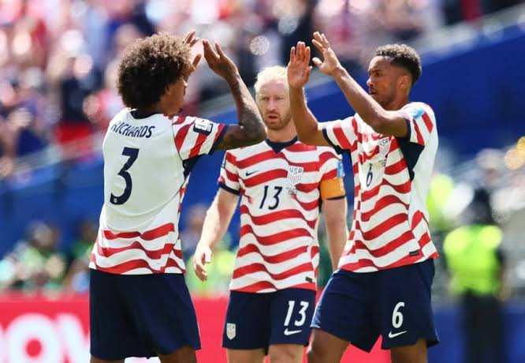
THE NEWS
The United States defeated Australia 2-0 in a Group D match at the 2026 FIFA World Cup. The game was played at Lumen Field in Seattle, with the US team taking full control from the start. With this result, the US now has six points from two matches and has advanced to the Round of 32.
Amerika Serikat mengalahkan Australia 2-0 dalam pertandingan Grup D Piala Dunia FIFA 2026. Pertandingan berlangsung di Lumen Field, Seattle, dengan tim AS menguasai permainan sejak awal. Dengan hasil ini, AS kini memiliki enam poin dari dua laga dan lolos ke babak 32 besar.

The US scored their first goal in the 13th minute when Australian defender Cameron Burgess accidentally kicked the ball into his own net. Just before halftime, Alex Freeman headed the ball in to make it 2-0. The VAR system checked if Freeman was offside, but the goal was confirmed.
AS mencetak gol pertama pada menit ke-13 saat bek Australia Cameron Burgess secara tidak sengaja menendang bola ke gawangnya sendiri. Tepat sebelum turun minum, Alex Freeman menyundul bola untuk menjadikan skor 2-0. Sistem VAR memeriksa apakah Freeman offside, namun gol tetap disahkan.

In the second half, Australia tried hard to score but the US defense stayed strong. Australia created one clear chance in the 61st minute, but the shot missed. The final score stayed at 2-0, making the US the first team in Group D to qualify for the knockout stage.
Pada babak kedua, Australia berusaha keras mencetak gol namun pertahanan AS tetap kokoh. Australia menciptakan satu peluang jelas di menit ke-61, namun tembakan meleset. Skor akhir tetap 2-0, menjadikan AS tim pertama di Grup D yang lolos ke babak gugur.

KEY VOCABULARY

English + Phonetic | Indonesian | Example
advance  /ədˈvæns/ | maju / lolos ke babak berikutnya | The US team will advance to the knockout stage after winning 2-0.  Tim AS akan maju ke babak gugur setelah menang 2-0.
victory  /ˈvɪktəri/ | kemenangan | The team celebrated their victory in front of thousands of fans at the stadium.  Tim merayakan kemenangan mereka di depan ribuan penonton di stadion.
own goal  /oʊn ɡoʊl/ | gol bunuh diri | The defender scored an own goal that helped the opponent take the lead.  Sang bek mencetak gol bunuh diri yang membantu lawan merebut keunggulan.
qualify  /ˈkwɑːlɪfaɪ/ | lolos / memenuhi syarat | Both teams are fighting hard to qualify for the next round of the tournament.  Kedua tim berjuang keras untuk lolos ke babak berikutnya dalam turnamen.
dominant  /ˈdɒmɪnənt/ | mendominasi / unggul | The US were dominant throughout the match, controlling the ball and creating many chances.  AS mendominasi sepanjang pertandingan, menguasai bola dan menciptakan banyak peluang.

PRACTICE READING
Read English first. Check the smaller gray Indonesian below.

The United States beat Australia 2-0 in the World Cup group stage.
Amerika Serikat mengalahkan Australia 2-0 di fase grup Piala Dunia.

Cameron Burgess accidentally scored an own goal in the first half.
Cameron Burgess secara tidak sengaja mencetak gol bunuh diri di babak pertama.

Alex Freeman headed the ball into the net to score the second goal.
Alex Freeman menyundul bola ke gawang untuk mencetak gol kedua.

USA now leads Group D with six points after two matches.
AS kini memimpin Grup D dengan enam poin setelah dua pertandingan.

Australia will need to win their next game to advance in the tournament.
Australia perlu memenangkan pertandingan berikutnya untuk maju di turnamen.

CONVERSATION

A: Did you watch the World Cup match last night?
Kamu nonton pertandingan Piala Dunia tadi malam?
B: Yes! The US beat Australia 2-0. It was a really exciting game!
Iya! AS mengalahkan Australia 2-0. Pertandingannya sungguh seru!
A: I heard the first goal was an own goal. Is that true?
Aku dengar gol pertama adalah gol bunuh diri. Benarkah itu?
B: That's right. An Australian defender accidentally kicked the ball into his own net.
Betul. Seorang bek Australia secara tidak sengaja menendang bola ke gawangnya sendiri.
A: And the second goal? Who scored it and how?
Lalu gol kedua? Siapa yang mencetak dan bagaimana caranya?
B: Alex Freeman headed it in just before halftime. The US played brilliantly the whole match.
Alex Freeman menyundulnya tepat sebelum turun minum. AS bermain brilian sepanjang pertandingan.

USEFUL EXPRESSIONS

"own goal" /oʊn ɡoʊl/
gol bunuh diri (saat pemain mencetak gol ke gawang timnya sendiri)

When a player accidentally scores a goal against their own team
"The own goal in the 13th minute gave the US an early advantage."
Gol bunuh diri di menit ke-13 memberi AS keunggulan awal.

"the final whistle" /ðə ˈfaɪnəl ˈwɪsəl/
peluit akhir pertandingan

The signal blown by the referee to officially end a football match
"The fans cheered loudly when the final whistle ended the match."
Para suporter bersorak keras ketika peluit akhir mengakhiri pertandingan.

"group stage" /ɡruːp steɪdʒ/
fase / babak penyisihan grup

The opening round of a tournament where teams compete in groups
"Teams must perform well in the group stage to reach the knockout rounds."
Tim-tim harus tampil baik di fase grup untuk mencapai babak gugur.

"pull off an upset" /pʊl ɒf ən ˈʌpset/
membuat kejutan besar (mengalahkan tim yang lebih kuat)

To win unexpectedly against a stronger or higher-ranked opponent
"Australia tried hard to pull off an upset but could not break through the US defense."
Australia berusaha keras membuat kejutan besar namun tidak mampu menembus pertahanan AS.

"net the ball" /net ðə bɔːl/
memasukkan bola ke gawang

To score a goal by kicking or heading the ball into the net
"Freeman jumped high to net the ball with a powerful header just before halftime."
Freeman melompat tinggi untuk memasukkan bola ke gawang dengan sundulan keras tepat sebelum turun minum.

